QUALITY POLICY
Brand Energy & Infrastructure
Services UK, Ltd.
Regent Park
299 Kingston Road
Leatherhead
Surrey
KT22 7SG
T +44 (0) 1372 381 300
F +44 (0) 1372 381 399

www.beis.com/uk

Brand Energy & Infrastructure Services UK, Ltd. is dedicated to the principle of continual improvement in quality and productivity, emphasising defect prevention rather than detection and the reduction of waste.

The policy of Brand Energy & Infrastructure Services UK, Ltd. is to:

• Operate a quality management system which meets the requirements of ISO9001.

• Supply on time quality products and services by aiming to exceed customer requirements.

• Establish strong relationships with both customers and suppliers.

• Utilise all available tools in the pursuit of continuous improvements, monitoring of our processes and to identify problems.
• Provide all our employees with training, resources and support needed to supply quality products and services to all our customers.
• Establish an environment that supports the production and delivery of high quality products and services.
• Encourage individuals to realise his or her full potential by actively encouraging and supporting a team approach.
• Actively encourage all employees to identify and resolve problems which impede efficient working.
• Create consistency of purpose towards quality and productivity in all aspects of our business to achieve competitiveness which will help us thrive and prosper.
• Annual review via Management Review of the effectiveness of the Quality Policy and Objectives.

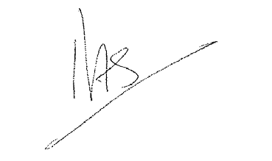Mick Herke David Stewart
Vice President Industrial Services Europe UK Forming & Shoring Director
February 2018 February 2018
Businesses: Brand (Industrial Services) & SGB (Commercial Scaffolding) Business: Hünnebeck (Formwork & Shoring)

SGB, Hünnebeck and Brand are trading names of Brand Energy & Infrastructure Services UK, Ltd.
© All Rights Reserved
Brand Energy & Infrastructure Services UK, Ltd., registered in England and Wales with company number 8729615, with registered office at Regent Park, 299 Kingston Road, Leatherhead, Surrey, England KT22 7SG.

